|  |
| --- |
| SupDuck 2JAVA Final Project |
|  |

By Samy Simon (291227) Published the 27/4/2020

Minimum Requirements

This game was made with Java and JavaFx (This Java library is needed to execute the code on an IDE)

To play this game (.exe or .jar) you will need :



Compatible Java Versions for the game: From 1.8.0 to 1.12.0

The Final game folder contains:

The Game code:



This User Guide :



The Duck.exe executable game :



The Duck.jar executable game :



Goal Of the Game

In this Game your ducks will have to eat as many lilies at they can in order to become a chief Duck (3 Lilies eaten).

Your duck will continuously shrink every seconds, if it doesn’t eat for too long, it will die.

Rocks will slow you down and makes the game harder by preventing you to get to the lilies in time !

Game Characters/Objects

   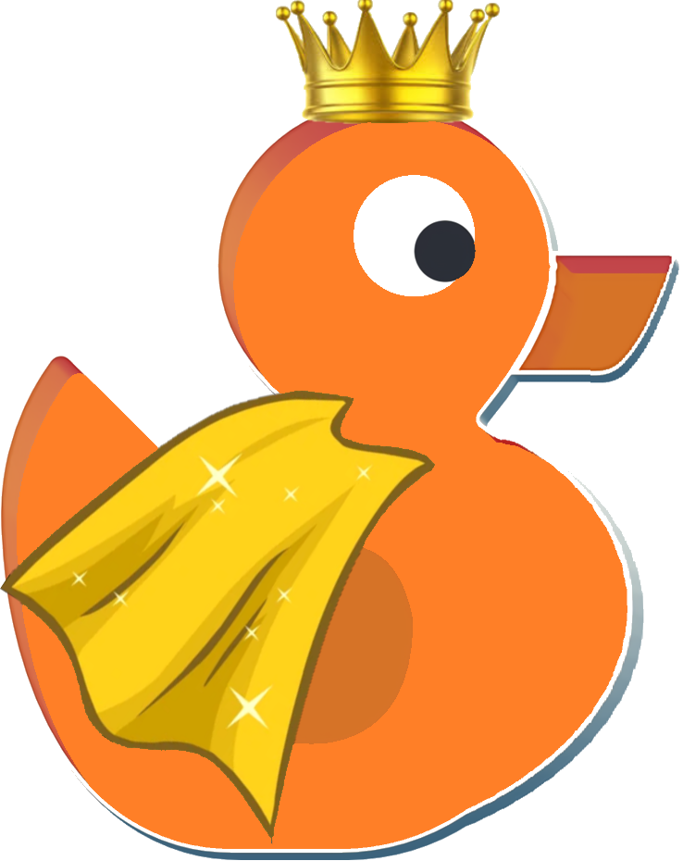

A Basic Duck A Water Lily A Rock A Chief Duck

The Map

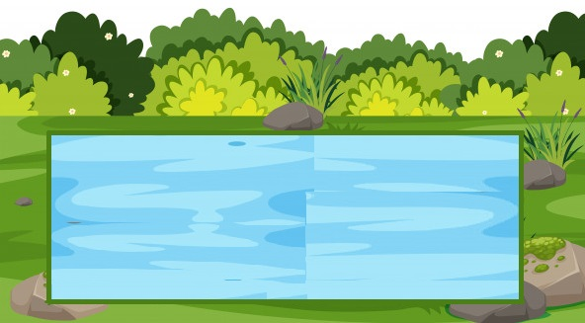

The map is a 1100x395(px) Pond that the ducks cannot escape

Game Characters/Objects Characteristics

 : The Basic Duck starts with 80HP, he will die if he goes under 50HP. He will evolve to a chief duck if he eats 3 lilies

 : The Water Lily spawns randomly, if a duck eats it, he will gain +15HP.

 : The rock spawns randomly as well, if a duck collides with it, he will change direction and loose time.

: The Chief Duck is invincible, if you’re lucky to have him, you will win when the game ends !

Game Characters/Objects Count at the start of the Game

   

3x Basic Duck 5x Water Lilies 5x Rocks 0x Chief Ducks

How to follow your duck(s) progress ?

All of your duck’s status are displayed and updated live in your duck board !

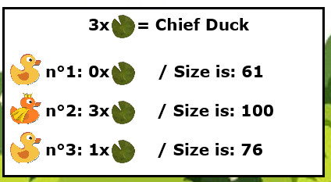

When can you lose ?

If all of your ducks go bellow 50HP, you will have no more ducks left in your pond and you will lose the game !

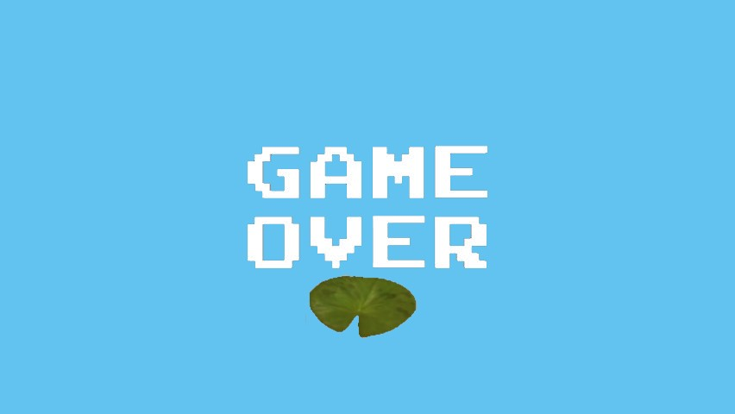

How to Win

If one of you’re basic ducks becomes a chief duck, when the other ducks disappear (or become chief ducks as well), you will win !

Step 1)

3x  

Step 2)



(Wait until all ducks disappear with time and game ends)

Step 3)

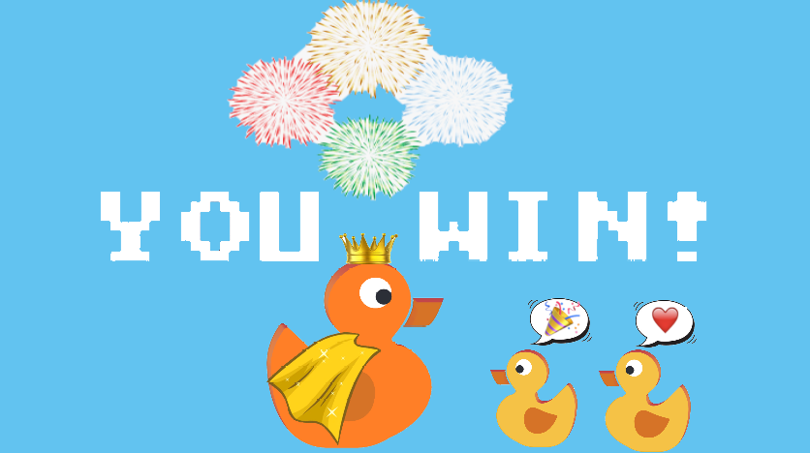

How to restart quickly the main game / Reset the pond



Simply press the Reset Game button in the top right corner during the game and you are good to go for a new game !

Good Luck and have fun !!!

